Project Planning Phase
Project Planning Template (Product Backlog, Sprint Planning, Stories, Story points)

Date | 15 February 2026
Team ID | LTVIP2026TMIDS24181
Project Name | ToyCraft Tales – Tableau’s Vision into Toy Manufacturer Data
Maximum Marks | 5 Marks

Product Backlog, Sprint Schedule, and Estimation (4 Marks)

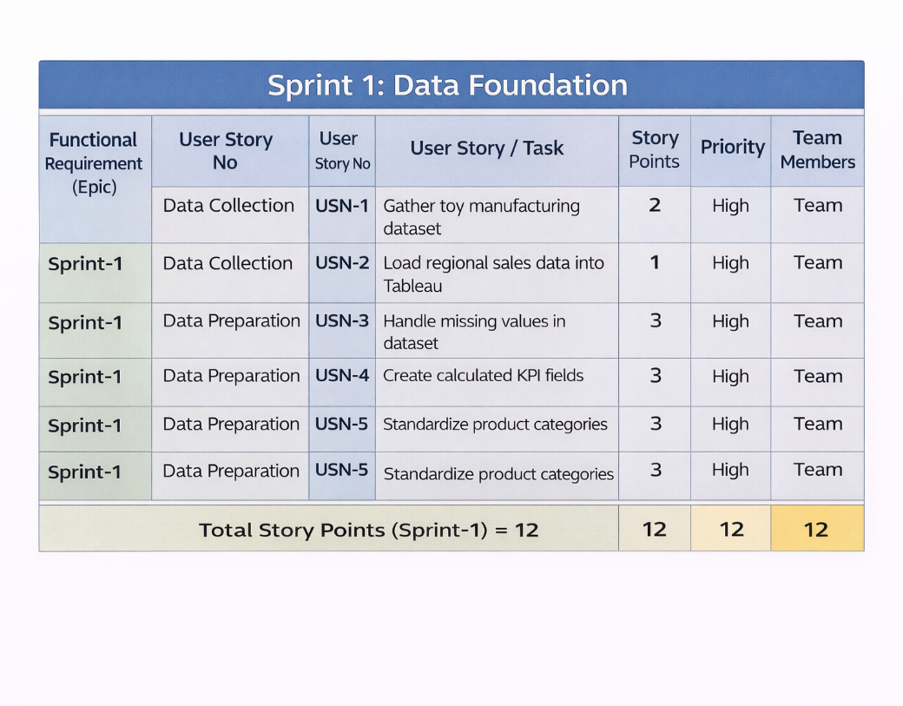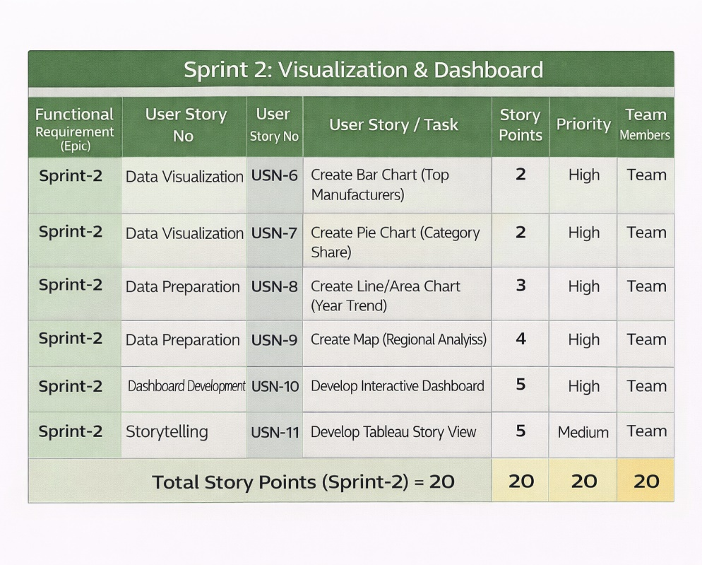
Project Tracker, Velocity & Burndown Chart: (4 Marks)
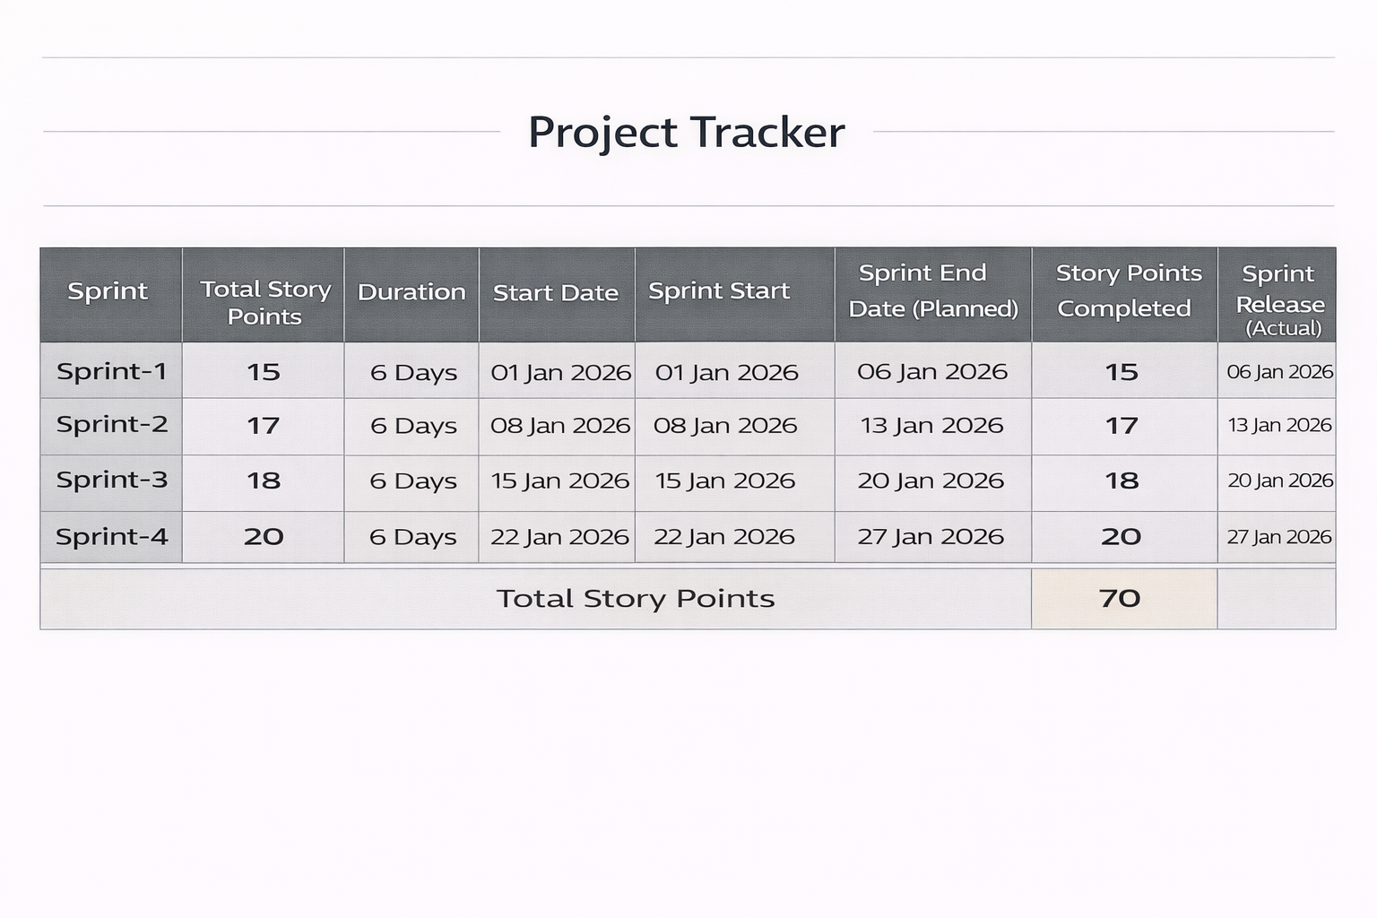

Velocity:
Imagine we have a 10-day sprint duration, and the velocity of the team is 20 (points per sprint). Let’s calculate the team’s average velocity (AV) per iteration unit (story points per day)

Total Story Points = 12 + 20 = 32
Number of Sprints = 2
Velocity = 32 / 2
Velocity = 16 Story Points per Sprint

Burndown Chart:
A burn down chart is a graphical representation of work left to do versus time. It is often used in agile software development methodologies such as Scrum. However, burn down charts can be applied to any project containing measurable progress over time.

https://www.visual-paradigm.com/scrum/scrum-burndown-chart/
https://www.atlassian.com/agile/tutorials/burndown-charts

Reference:
https://www.atlassian.com/agile/project-management
https://www.atlassian.com/agile/tutorials/how-to-do-scrum-with-jira-software
https://www.atlassian.com/agile/tutorials/epics
https://www.atlassian.com/agile/tutorials/sprints
https://www.atlassian.com/agile/project-management/estimation
https://www.atlassian.com/agile/tutorials/burndown-charts

